**DAILY ONLINE ACTIVITIES SUMMARY**

|  |  |  |  |  |  |  |  |  |  |  |  |  |  |
| --- | --- | --- | --- | --- | --- | --- | --- | --- | --- | --- | --- | --- | --- |
|  | **Date:** | |  | **10-06-2020** | | |  |  | **Name:** | | **Suhas Prasad Shetty** | | |
|  |  |  |  |  |  |  |  |  |  |  |  |  |  |
|  | **Sem & Sec** | |  | **8th sem B sec** | | |  |  | **USN:** | | **4AL16CS080** | | |
|  |  |  |  |  |  |  |  |  |  |  |  |  |  |
|  |  |  |  |  |  |  | **Online Test** | | **Summary** | |  |  |  |
|  |  |  | |  |  |  |  |  |  |  |  |  |  |
|  | **Subject** | | |  | **-** |  |  |  |  |  |  |  |  |
|  |  |  | |  |  |  |  |  | |  |  |  |  |
|  | **Max. Marks** | | |  | **-** |  |  | **Score** | | | **-** |  |  |
|  |  |  |  |  |  |  | |  | |  |  |  |  |
|  |  |  |  |  |  | **Certification Course Summary** | | | | | | | |
|  |  |  | |  | |  |  |  |  |  |  |  |  |
|  | **Course** | |  | **Machine Learning Terminology and Process** | | |  |  |  |  |  |  |  |
|  |  |  |  | | |  |  |  | |  |  |  |  |
|  | **Certificate Provider** | | | | | **AWS** |  | **Duration** | | |  | **60mins** |  |
|  |  |  |  |  |  |  |  |  | |  |  |  |  |
|  |  |  |  |  |  |  | **Coding Challenges** | | | |  |  |  |
|  |  | | | | | |  |  |  |  |  |  |  |
|  | **Problem Statement-** : | | | | | |  |  |  |  |  |  |  |
|  |  |  | | | | | |  | |  |  |  |  |
|  | *1) Python* | *program takes a number and reverses it* | | | | | | | |  |  |  |  |
|  |  | | | | | |  |  |  |  |  |  |  |
|  | **Status: completed** | | | | | |  |  |  |  |  |  |  |
|  |  | | | | | |  |  | | |  |  |  |
|  | **Uploaded the report in Github** | | | | | |  | **yes** | | |  |  |  |
|  |  | | | | | |  |  | | |  |  |  |
|  | **If yes Repository name** | | | | | |  | **Suhas** | | |  |  |  |
|  |  | | | | | |  |  | | |  |  |  |
|  | **Uploaded the report in slack** | | | | | |  | **yes** | | |  |  |  |
|  |  |  |  |  |  |  |  |  |  |  |  |  |  |

**Certification Course Details**

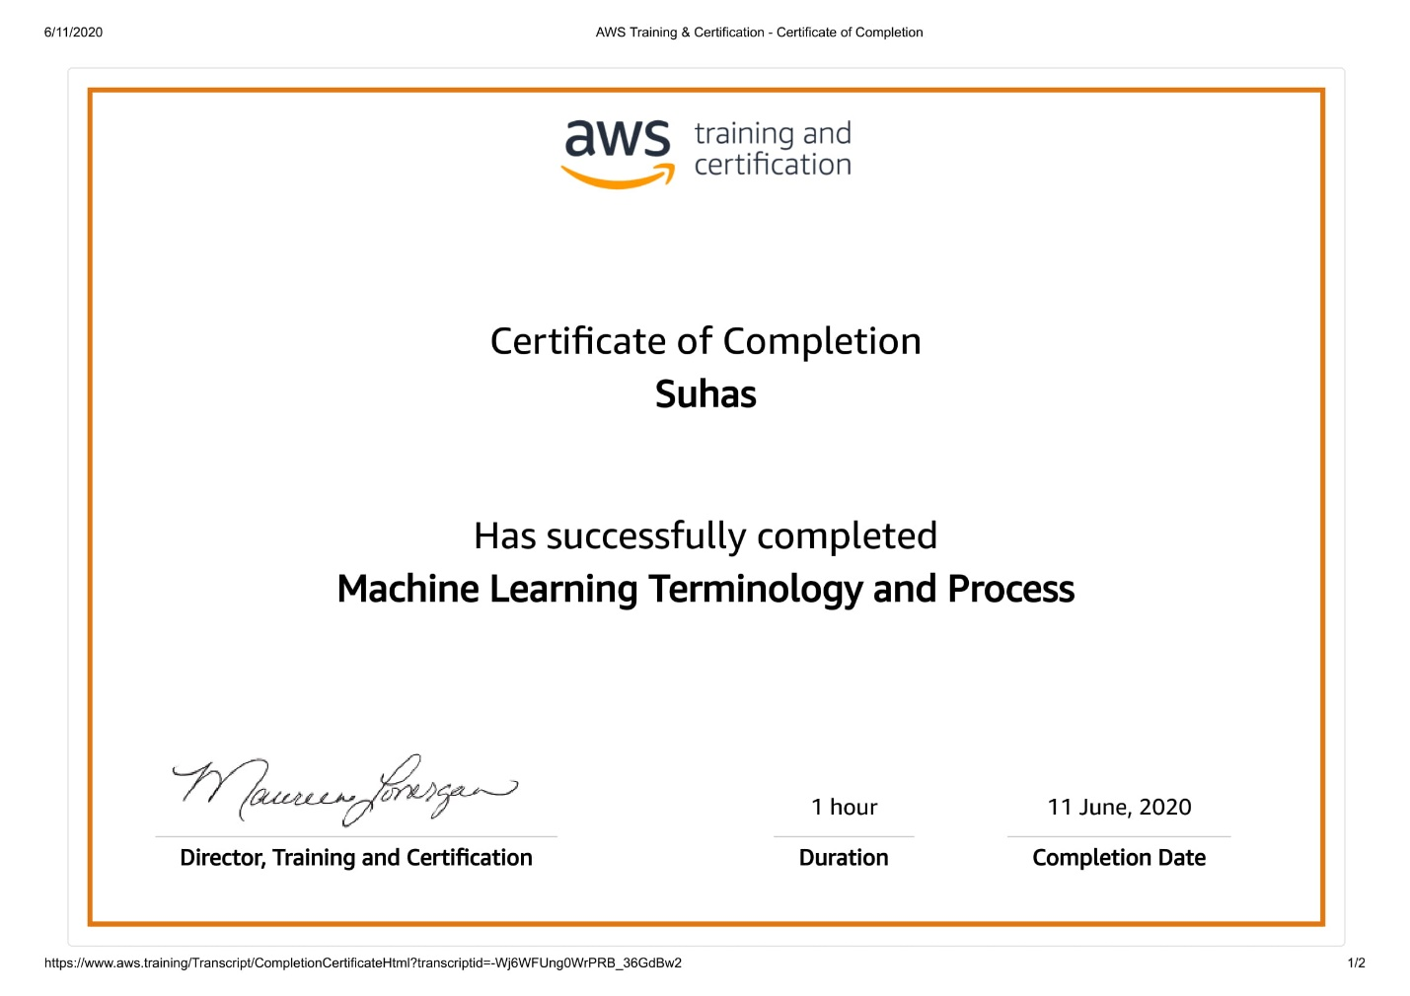

**Coding Challenges Details**

**Program no:1**

n=int(input("Enter number: "))

rev=0

**while**(n>0):

dig=n%10

rev=rev*10+dig

n=n//10

**print**("Reverse of the number:",rev)